**American Literature II**

**English 262**

***Paper 2.3: A Linguistic Artifact and Critique (20%)***

**Due at the Start of Class on 11 April 2023**

**3-page suggested length**

Addie’s narrative is unsettling, as she communicates through violence the sentiments we are used to hearing in beatific language: motherhood, love, virginity, and the purpose of being. Her narrative highlights what or whom she’s arguing against: Anse, her father, Cora, and the social conventions that each of them use to confine her. Seeing Anse exploit “neighborliness” or “family,” it’s no wonder Addie recoils from such words. Similarly, Dewey Dell’s reluctance or inability to put her experience into words makes her vulnerable to those who will fill in “female troubles” and “payment” as they please.

Now it’s your turn. Even (or especially) if we don’t like Addie’s approach, I’m going to ask you to create your own expression of something you believe to be valuable. **How do you give shape to an experience in your life?** What do you think is important enough to say well? What era or culture of English will help you get your meaning across? Where or how does conventional language let you down in attempting to convey that thing of value? Does “love” remain powerful if we can say “I love you” *and* “I love acrylic nails”? Think carefully about voice, form, subject, and your relationship to established linguistic conventions. Can we build something that doesn’t leave Addie shaking her head at a “lack,” but that also satisfies us more than her vengeance?

Your submission should contain **two things**: **a linguistic artifact** of your own making (a poem, a brief statement, manifesto, or essay) and also **an explanation** of which tools you drew on, what baggage these conventions carry, and how you crafted something that felt *new* while drawing on existing forms that are intelligible to your reader. How you combine these two elements is entirely up to you; you can weave together the critique and the artifact, as Addie does, or simply tackle one at a time. The form is entirely up to you, though I’ve given a page suggestion to encourage you to keep your entries tight.

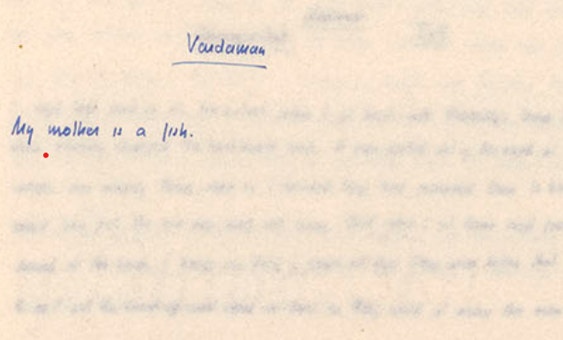*Where to begin?* As with our usual literary analyses, I would encourage you to return to your commonplaces. You don’t have to “write like Faulkner” (please don’t), but he reminds us both of the flexibility of language andhow much it draws on existing conventions. Consider listening to cafeteria conversations, cracking open old books, and considering the way in which non-native English speakers craft their English sentences. Language is carved out, after all, and English-language learners can help us attend to the methods of such craft. Think of the way Cash articulates value through carpentry: do the rules of carpentry minimize or amplify the way he values the human body? How does the white space around Vardman’s “My mother is a fish” chapter affect whether we dismiss or treasure his statement?[1]

1. More manuscript examples available here:

   <http://faulkner.drupal.shanti.virginia.edu/node/8495?canvas>